# Angular

**Materials and resources:**

<https://angular.io/docs>

<https://cli.angular.io/>

<https://www.dunebook.com/from-zero-to-hero-learn-angularstrap-from-scratch/>

<http://www.netinstructions.com/100-days-of-angular-2/?utm_source=mybridge&utm_medium=web&utm_campaign=read_more>

<https://github.com/johnpapa/angular-styleguide/blob/master/a2/README.md>

<https://legacy.gitbook.com/book/basarat/typescript/details>

<https://basarat.gitbooks.io/typescript/>

<https://www.youtube.com/watch?v=qRD7bkK7m10>

<https://thinkster.io/tutorials/learn-angular-2>

<https://www.tutorialspoint.com/angular2/>

Books: ng-book2-r37

**Assignments:**

Now when we have the admin layout and categories list page let’s add ‘Add’ and ‘Edit’ category.

### 1 Task: Add Category

* When user select ‘Add new’ button following page is open.
* ‘Name’ field is a required field
* On click on a ‘Save’ button category is saved and the user is redirected to ‘Categories list page’
* On click on a ‘Cancel’ button, the user is redirected to ‘Categories list page’

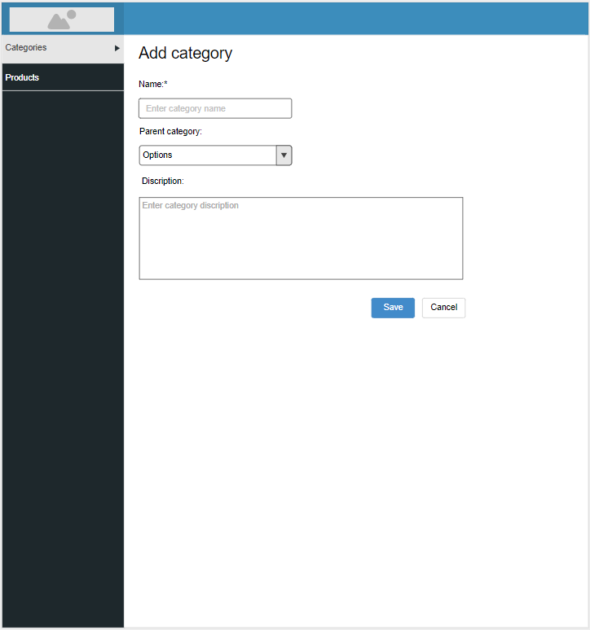

Admin: Category add page

### 2 Task: Edit Category

When a user clicks on ‘Edit’ button on some item from ‘Categories list page’ is redirected on ‘Category edit page’. All fields are prepopulated with the data. The user can change the data and on click on ‘Save’ button changes are saved and the user is redirected on ‘Category list page’. On click on ‘Cancel’ button, changes are not saved, the user is redirected on ‘Category list page’.

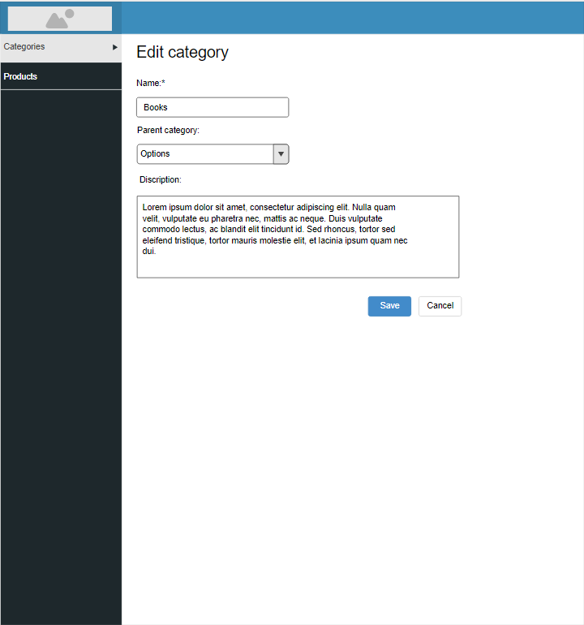

Admin: Category edit page